The Dog Ate My Homework !

Look carefully at the cartoon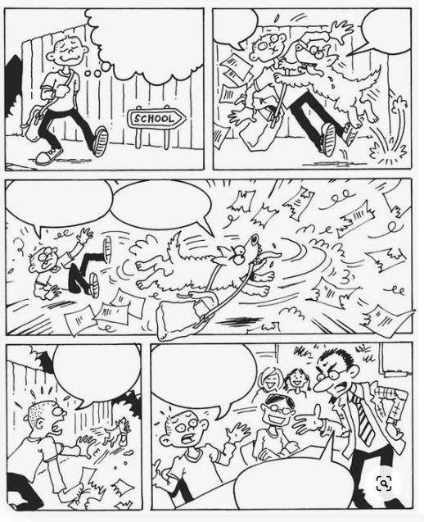
Now tell the story of how the dog ate your homework and how you have to explain that to the teacher.

Used the lined pages to write on.

Colour the cartoon when you have finished.

